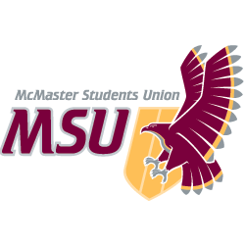 | JOB DESCRIPTION  Hourly Staff

Position Title: | TwelvEighty - Barback
Term of Office: | May 1 to April 30
Supervisor: | Restaurant Manager and Night Club Manager
Remuneration: | Refer to MSU OPERATING POLICY 2.2 - EMPLOYMENT (WAGES)
Hours of Work: | Academic (variable); summer (as needed)

General Scope of Duties
To ensure that the bar area is sufficiently stocked with beverage and other related product as to allow smooth nightly operation for the bartender. Continuous maintenance of the bar environment to ensure safety and cleanliness.

Major Duties and Responsibilities
Category | Percent | Specifics
Operations Function | 75% | - Ensure bar area is sufficiently stocked with fresh product, garnish and glassware  - Keep bar environment clear of empty glassware and bottles  - Ensure cleanliness of entire establishment  - Careful tracking of inventory placement of beverage product throughout the night
Other | 25% | - Opening, closing and side duties as per Twelve Eighty cleaning systems  - Ongoing cleanliness  - Be ready for your shift in proper uniform and have bars stocked and ready for business

Knowledge, Skills and Abilities
- Must have organizational and time management skills
- Background in customer service oriented industry
- Must have ability to work efficiently at a fast pace

Effort & Responsibility
- Ability to make decisions quickly and often without warning
- Tracking of large amounts of beverage product

Working Conditions
- Work environment is fast and challenging. Often the barback is performing several tasks simultaneously
- Loud volume, noisy, environment
- Potential risk of personal injury
- Late evenings and weekends

Training and Experience
- Inventory tracking experience
- Past bar/restaurant experience preferred
- Experience in campus environment preferred
- Some computer experience an asset

Equipment
- P.O.S. system, audio equipment, drafts dispensing equipment, sharp knives, and blenders

